

CSBG Performance Management Website
  - Exercise Guide 01

Contents
ICON KEY iii
Purpose iv
Using this Exercise Guide iv
Scenario 1 1
Exercise 1 1
Scenario 1 Solution 2
Scenario 1 Result 5
Scenario 2 6
Exercise 2 6
Scenario 2 Solution 7
Scenario 2 Result 9
Scenario 3 10
Exercise 3 10
Scenario 3 Solution 11
Scenario 3 Result 14
Scenario 4 15
Exercise 4 15
Scenario 4 Solution 16
Scenario 4 Result 19
Scenario 5 20
Exercise 5 20
Scenario 5 Solution 21
Scenario 5 Result 24
Scenario 6 25
Exercise 6 25
Scenario 6 Solution 26
Scenario 6 Result 29

ICON KEY
Throughout this guide, you’ll notice a few icons. This page briefly explains the significance of the icons.

Swimming Icons

The swimming icons are in each report created within this guide to represent a level of expertise in creating reports.

Puzzle Icon
The puzzle icon represents the ability to jump to other sections within this guide by clicking the linked text right below it.

Purpose
The purpose of this Exercise Guide is to show how to use the Community Services Block Grant (CSBG) Performance Management website to generate different reports, which will assist CSBG lead agencies in navigating and learning the features of the website.

The scenarios are examples of questions that a stakeholder may ask, and the reports provided are examples of how the questions from a stakeholder can be answered.

Please note these are steppingstones to developing expertise in using the website. Overtime, the aim is developing the ability to use the website to answer different stakeholder questions from the unique perspective of each state, territory, and CSBG eligible entity.

Using this Exercise Guide
- Review the scenario, which includes a question from a CSBG stakeholder and how the CSBG State Administrator chooses to respond.
- Attempt the exercise to create the report.
- Review the solution steps for each scenario.
- Compare your report to the final result.

Scenario 1

Wade In

A CSBG stakeholder asks, “What was the impact of CSBG on employment outcomes for our state in (Fiscal Year) FY 2021?”

As the CSBG Administrator, you review the Employment Family and Individuals National Performance Indicators (FNPIs) that the CSBG eligible entities in your state reported in 2021. After review, you choose to use FNPI 1g, Unemployed Adults Who Obtained and Maintained Employment for at Least 180 Days with a Living Wage or Higher, to show the impact of employment outcomes.

Exercise 1
Using Advanced Data & Analytics, generate a report to show the state-level data for FNPI 1g for FY21.

Scenario 1 Solution
Scenario 1 Result
Scenario 2

Scenario 1 Solution

STEP 1: Once in the Data Warehouse, select the Advanced Data & Analytics option.

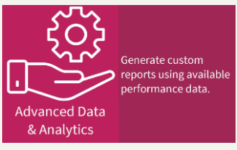

STEP 2: Under Step 1, select your years of interest as well as the geographic level of data you are interested in. For this example, select “2021,” “State Data,” and your state.

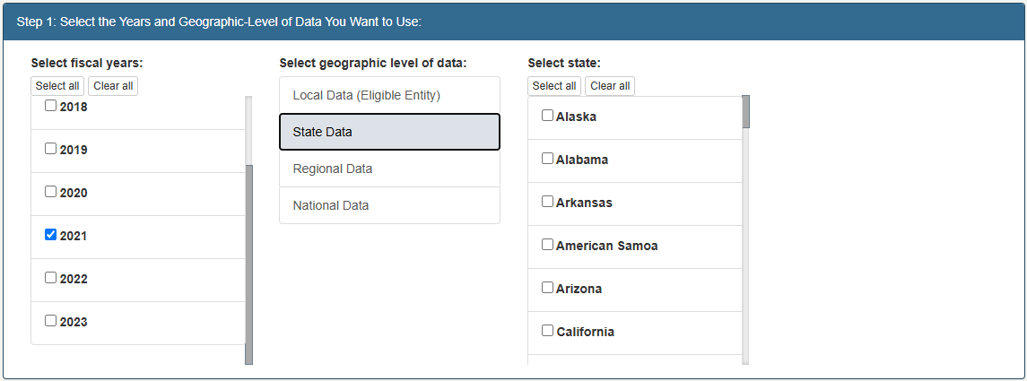

STEP 3: Under Step 2, select the topic area “Individual and Family National Performance Indicators (FNPIs) (Module 4)- State.” Then, select the sub-topic “Employment (FNPI 1)” and the data field “FNPI 1g, Unemployed Adults Who Obtained and Maintained Employment for at Least 180 Days with a Living Wage or Higher (Statewide Total).”

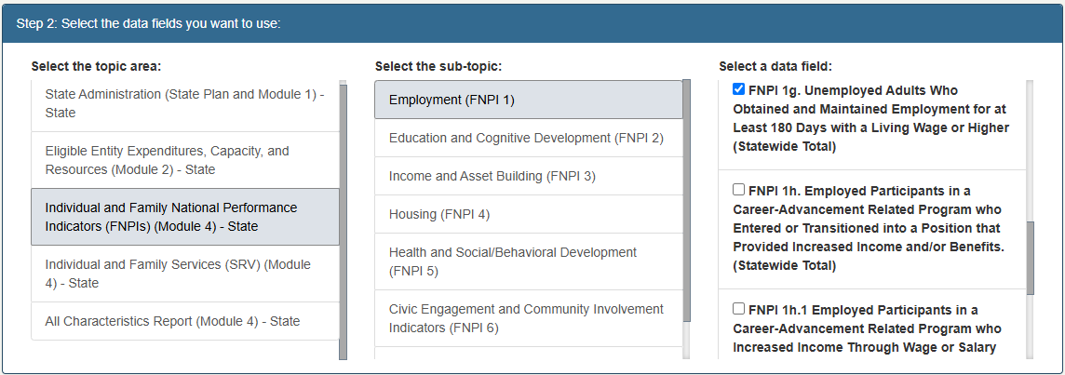

STEP 4: Under Step 3, you can add optional filters. Since all the columns are already selected, we will make no changes in this step.

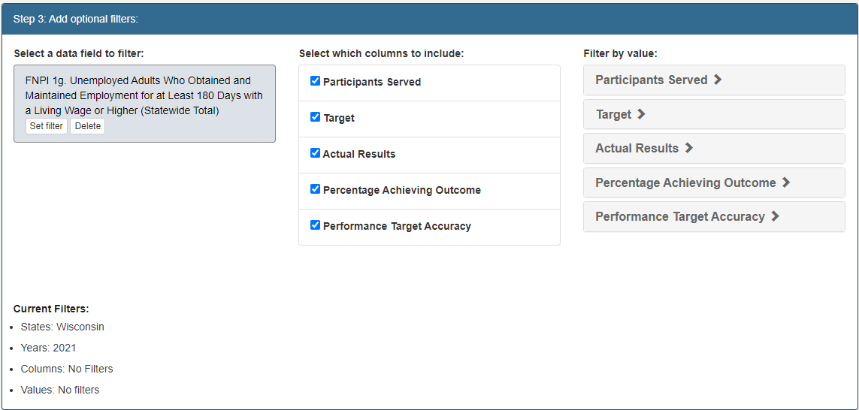
[Grab your reader’s attention with a great quote from the document or use this space to emphasize a key point. To place this text box anywhere on the page, just drag it.]

STEP 5: In the final step, we can create a data table. Select “Data table only” under “Select how to display your data,” and name your report “Statewide Outcomes for FNPI1g” with the description “FY21.” To generate your report, select “Create Data Report.”

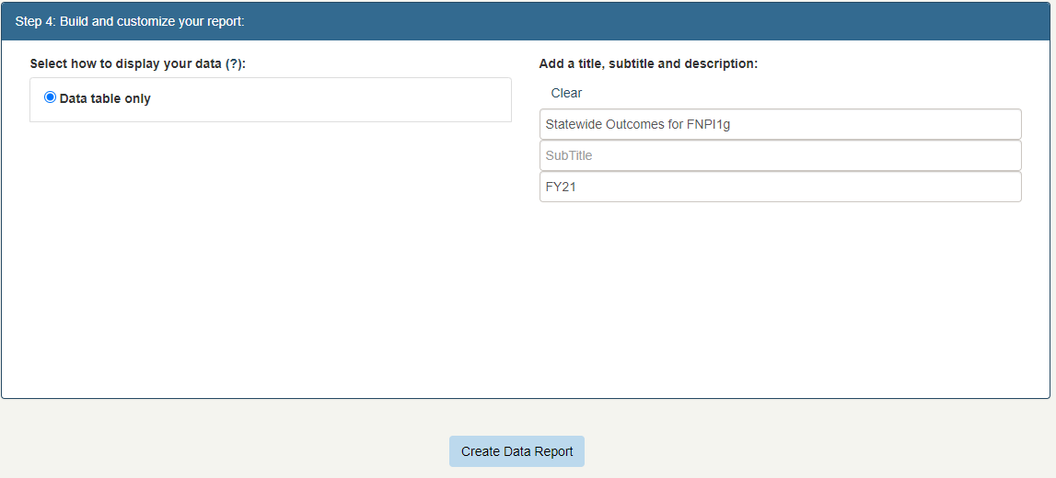

Scenario 1 Result

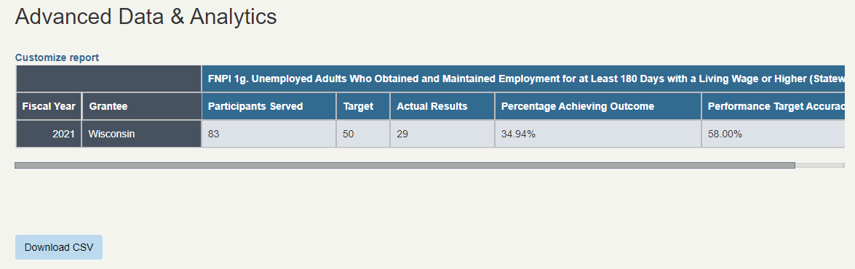
[Grab your reader’s attention with a great quote from the document or use this space to emphasize a key point. To place this text box anywhere on the page, just drag it.]

Scenario 1

Scenario 2

Jump In

After continued discussion with the CSBG stakeholder, you decide to revise the report to include FNPI 1c, Unemployed Adults Who Obtained and Maintained Employment for at Least 90 Days Up to a Living Wage.

Exercise 2
Using the Customize report button, revise your report to add information about FNPI 1c.

Scenario 2 Solution
Scenario 2 Result
Scenario 1
Scenario 3

Scenario 2 Solution

STEP 1: To customize your previous report, select the “Customize report” button at the top of the report.

[Grab your reader’s attention with a great quote from the document or use this space to emphasize a key point. To place this text box anywhere on the page, just drag it.]

STEP 2: Under Step 1 of the customize screen, some criteria will already be selected from our previous report—including the year (2021), the geography (State Data), and state. For this example, we will not make any changes to this step.

STEP 3: Under step 2 of the customize screen, we want to add an additional data field. Retain the criteria that is already selected for topic area (“Individual and Family National Performance Indicators (FNPIs) (Module 4) - State”) and sub-topic (“Employment (FNPI 1)”). In the data field column, FNPI1g should already be selected. We will also select “FNPI 1c, Unemployed Adults Who Obtained and Maintained Employment for at Least 90 Days Up to a Living Wage (Statewide Total).”

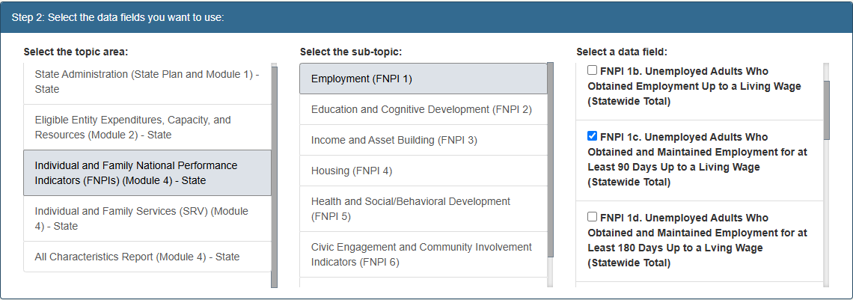

For this exercise, you can skip Step 3 of the customization.

STEP 4: Under Step 4, ensure that “Data table only” is still selected. You can update the title as needed, then click “Create Data Report.”
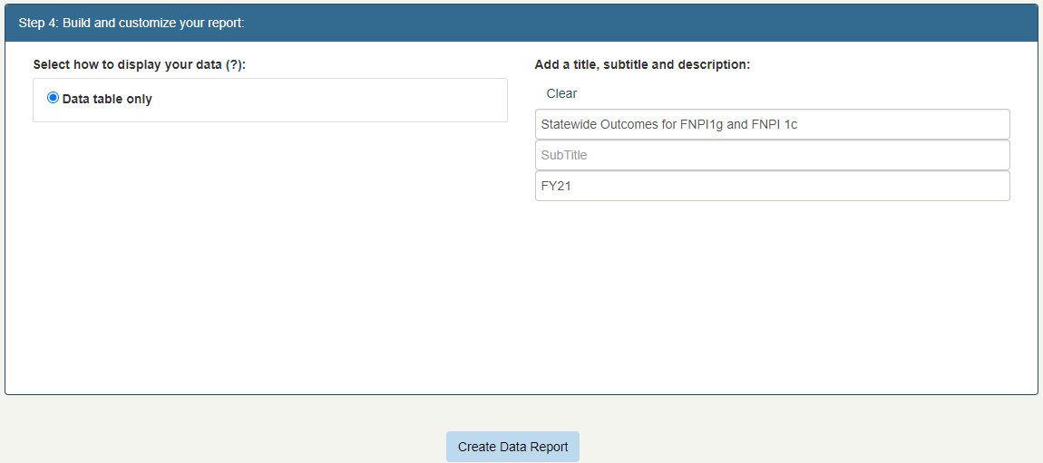

Scenario 2 Result

You may need to scroll to see all the data.

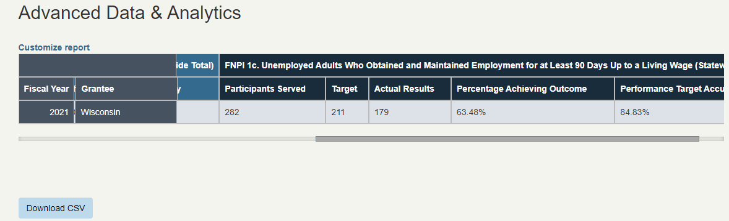
[Grab your reader’s attention with a great quote from the document or use this space to emphasize a key point. To place this text box anywhere on the page, just drag it.]

Scenario 2

Scenario 3
Wade In

After continued discussion, the CSBG stakeholder asks you for information about how CSBG funds contributed to producing those outcomes

As the CSBG Administrator, you decide to generate a report showing the CSBG expenditures by domain.

Exercise 3
Using Advanced Data & Analytics, generate a report to show the state-level data for CSBG expenditures by domain for FY21.

Scenario 3 Solution
Scenario 3 Result
Scenario 2
Scenario 4

Scenario 3 Solution

STEP 1: Once in the Data Warehouse, select the Advanced Data & Analytics option.

STEP 2: Under Step 1, select your years of interest as well as the geographic level of data you are interested in. For this example, select “2021,” “State Data,” and your state.

4

STEP 3: Under Step 2, select the topic area “Eligible Entity Expenditures, Capacity, and Resources (Module 2)- State.” Then, select the sub-topic “Expenditures” and the data field “CSBG Expenditure Domains (Statewide Total).”

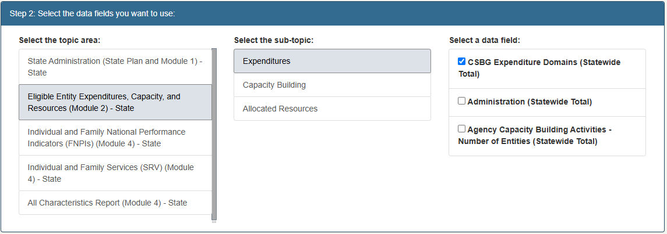

STEP 4: Under Step 3, you can add optional filters. Since all the columns are already selected, we will make no changes in this step.

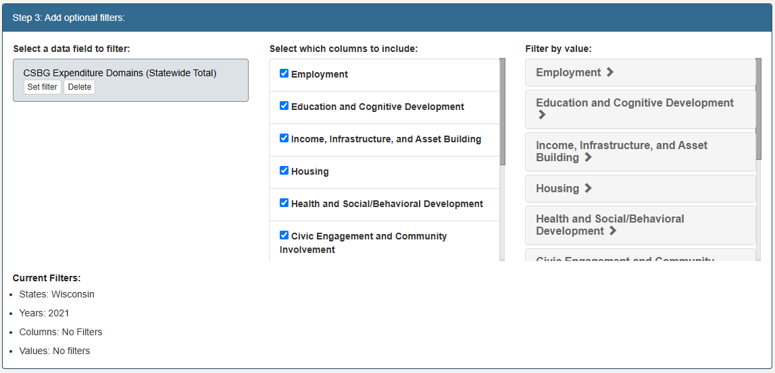
[Grab your reader’s attention with a great quote from the document or use this space to emphasize a key point. To place this text box anywhere on the page, just drag it.]

STEP 5: Under Step 4, we have options on how to display the data. For this report, select “Bar graph.” Then, we can name our report “CSBG Spending by Domain- Statewide” and add the description “FY21.” From there, select Create Data Report.

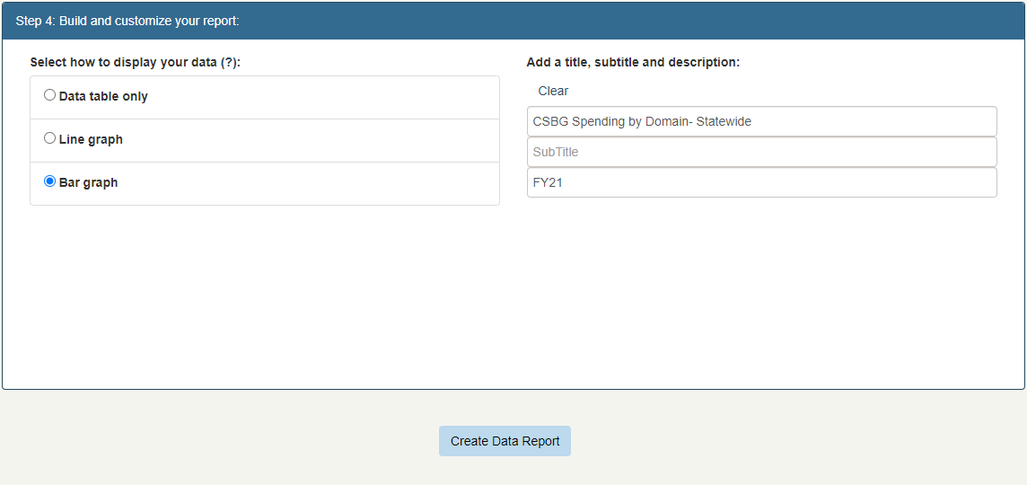

Scenario 3 Result

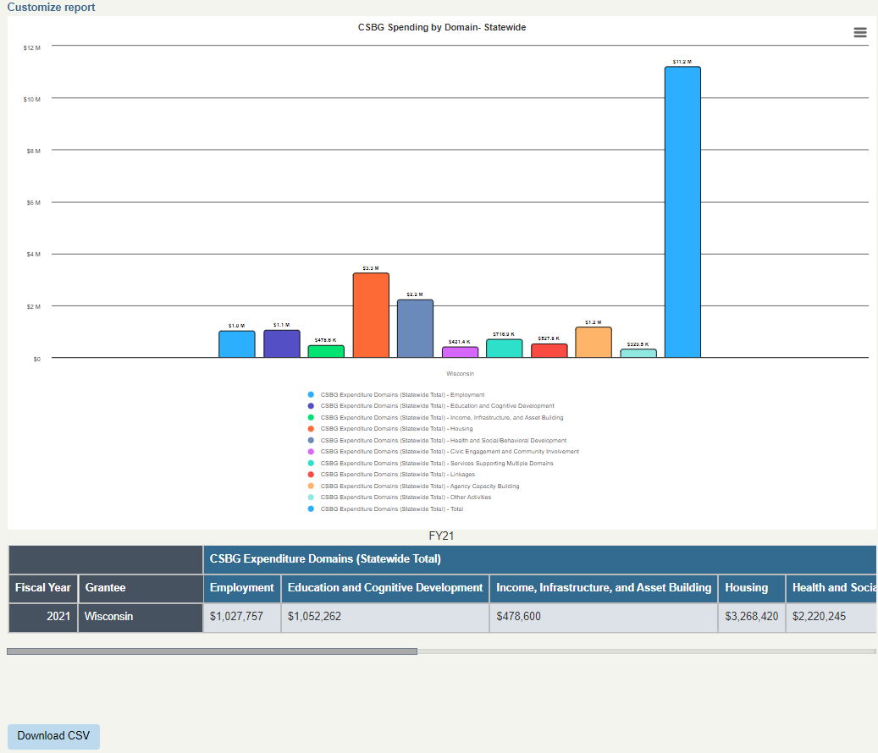
[Grab your reader’s attention with a great quote from the document or use this space to emphasize a key point. To place this text box anywhere on the page, just drag it.]

Scenario 3

Scenario 4
Jump In

The stakeholder is now interested in what services were provided by CSBG eligible entities that were supported by the funds in the CSBG expenditure domain.

You decide to generate a generate a report showing the Employment Services across the state.

Exercise 4
Using the Customize report button, generate a report to show your stakeholder the number of individuals served for each employment service provided by the CSBG eligible entities in FY21.

Scenario 4 Solution
Scenario 4 Result
Scenario 3
Scenario 5

Scenario 4 Solution

STEP 1: Starting on the results page from the previous example, click “Customize report” at the top of the page.

[Grab your reader’s attention with a great quote from the document or use this space to emphasize a key point. To place this text box anywhere on the page, just drag it.]

STEP 2: Under Step 1 of the customize screen, some criteria will already be selected from our previous report—including the year (2021), the geography (State Data), and state. For this example, we will not make any changes to this step.

STEP 3: Under step 2 of the customize screen, select “Individual and Family Services (SRV) (Module 4) - State,” then select “Employment Services (SRV 1)” to view employment services, and finally select all the data fields available in the data field column.

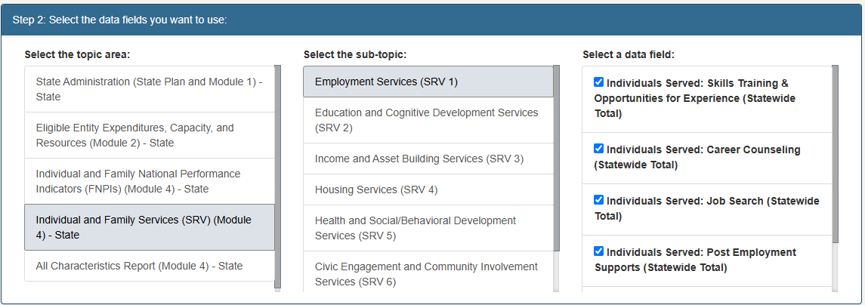

STEP 4: Under Step 3, you do not have to change any filters for the data fields, but we do want to delete the data field from our previous report. To do so, select “Delete” in the “CSBG Expenditure Domains (Statewide Total)” data field.

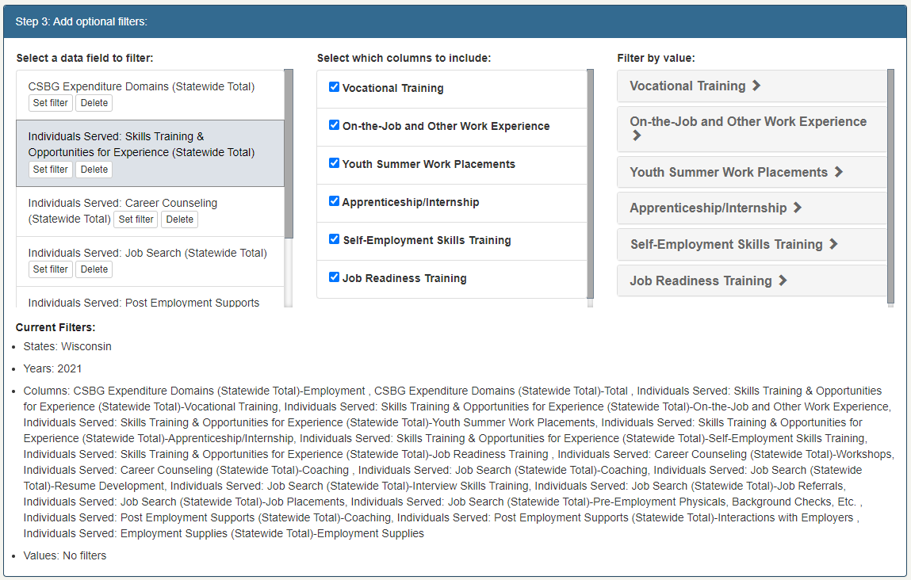
[Grab your reader’s attention with a great quote from the document or use this space to emphasize a key point. To place this text box anywhere on the page, just drag it.]

STEP 5: Under Step 4, ensure that “Bar graph” is selected. You can update the title as needed, then click “Create Data Report.”
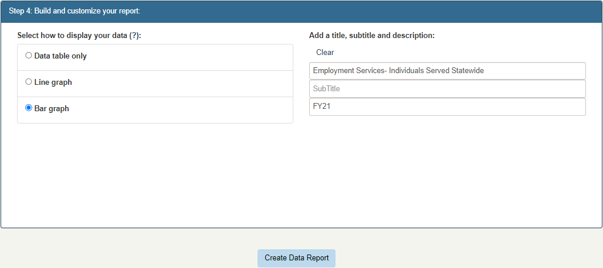

Scenario 4 Result

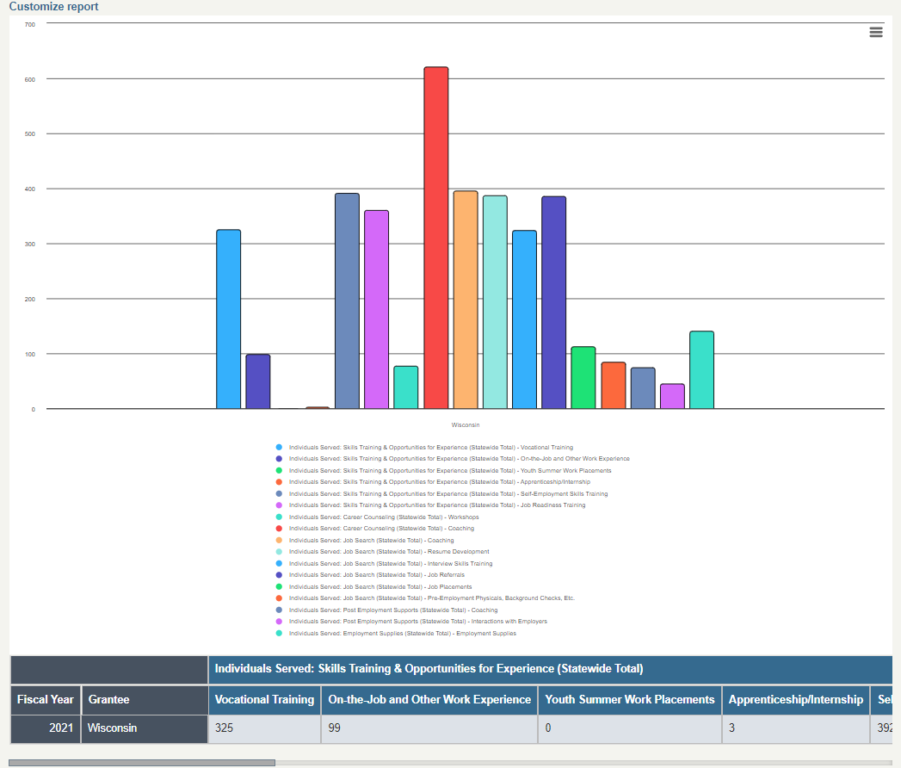
[Grab your reader’s attention with a great quote from the document or use this space to emphasize a key point. To place this text box anywhere on the page, just drag it.]

Scenario 4

Scenario 5
Wade In

After seeing this report, the stakeholder then asks, “how important is it for CSBG to help support the employment programs implemented by the CSBG eligible entities?”

You decide to show the work status of participants for those served by CSBG to demonstrate participant need.

Exercise 5
Using Advanced Data & Analytics, generate a report to show how many participants your state has information about work status for FY21.

Scenario 5 Solution
Scenario 5 Result
Scenario 4
Scenario 6

Scenario 5 Solution

STEP 1: Once in the Data Warehouse, select the Advanced Data & Analytics option.

STEP 2: Under Step 1, select your years of interest as well as the geographic level of data you are interested in. For this example, select “2021,” “State Data,” and your state.

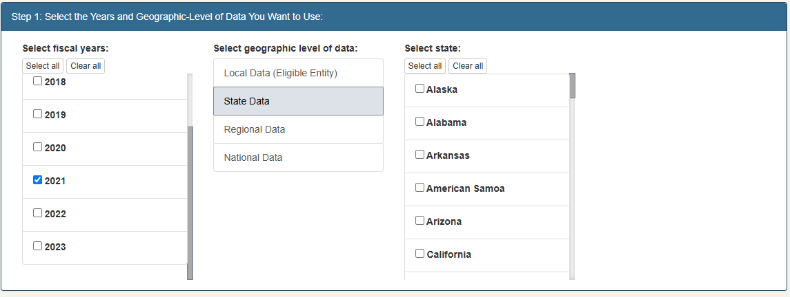

STEP 3: Under Step 2, select the topic area “All Characteristics Report (Module 4) - State.” Then, select the sub-topic “Individual Level Characteristics” and the data field “Work Status (Individuals 18+) (Statewide Total).”

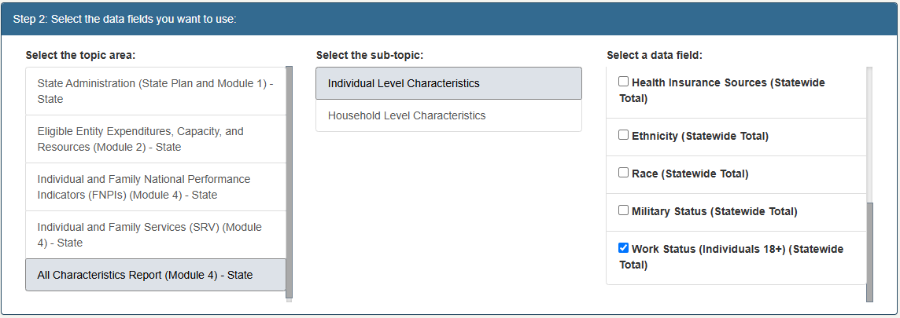

STEP 4: Under Step 3, you can add optional filters. For this exercise, we want to unselect all types of work status data and only keep two columns: “Unknown and Not Reported” and “Total.”

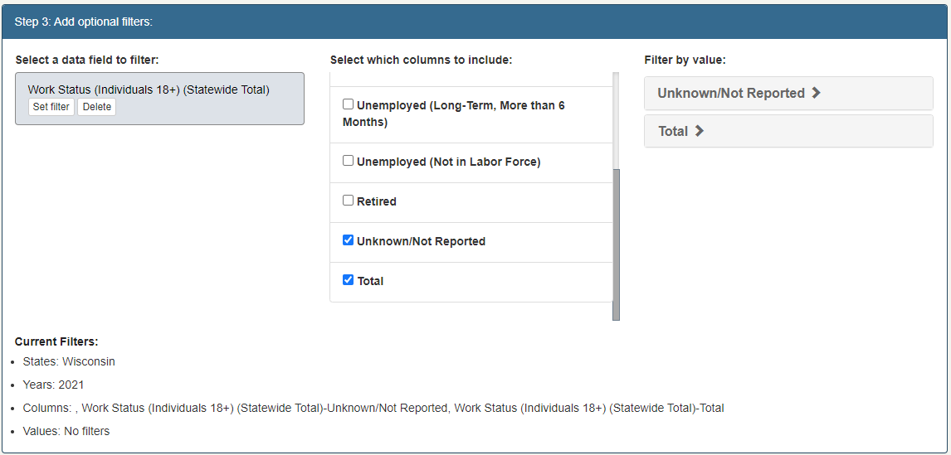

STEP 5: In the final step, select “Bar graph” under “Select how to display your data,” and name your report. To generate your report, select “Create Data Report.”

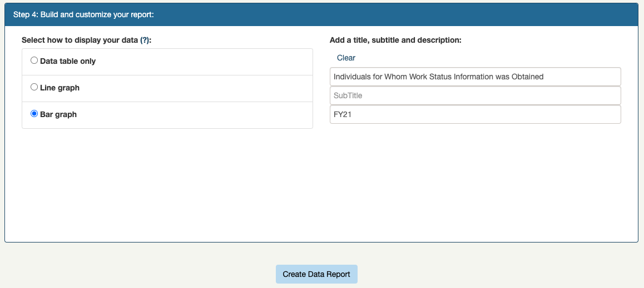

Scenario 5 Result

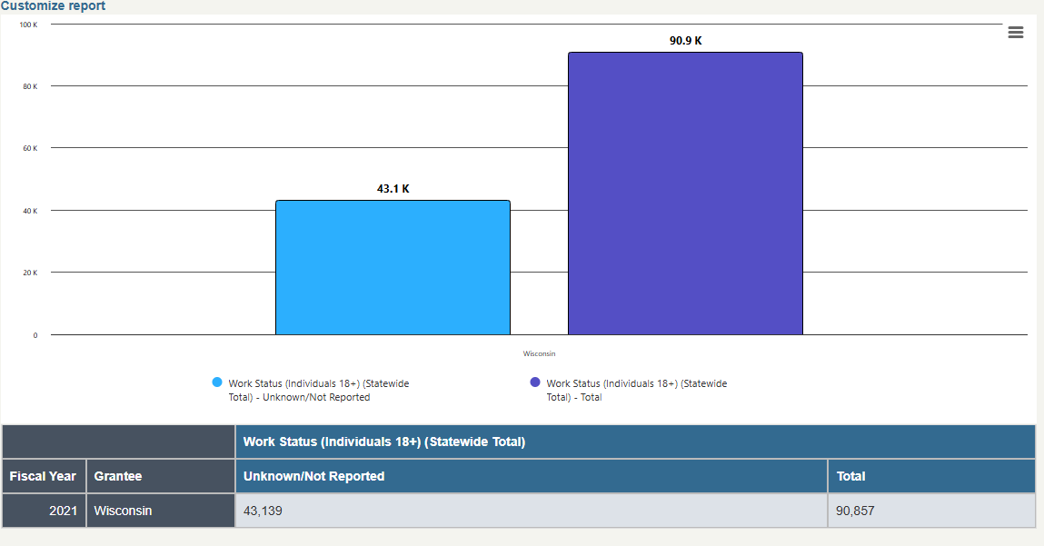

Scenario 5

Scenario 6
Jump In

Now that you established for how many participants your state has work status information, you decide to also show the stakeholder the known work status for each participant.

Exercise 6
Using the Customize report button, revise your report to show the known work status for each participant.

Scenario 6 Solution
Scenario 6 Result
Scenario 5

Scenario 6 Solution

STEP 1: To customize your previous report, select the “Customize report” button at the top of the report.

STEP 2: Under Step 1 of the customize screen, some criteria will already be selected from our previous report—including the year (2021), the geography (State Data), and state. For this example, we will not make any changes to this step.

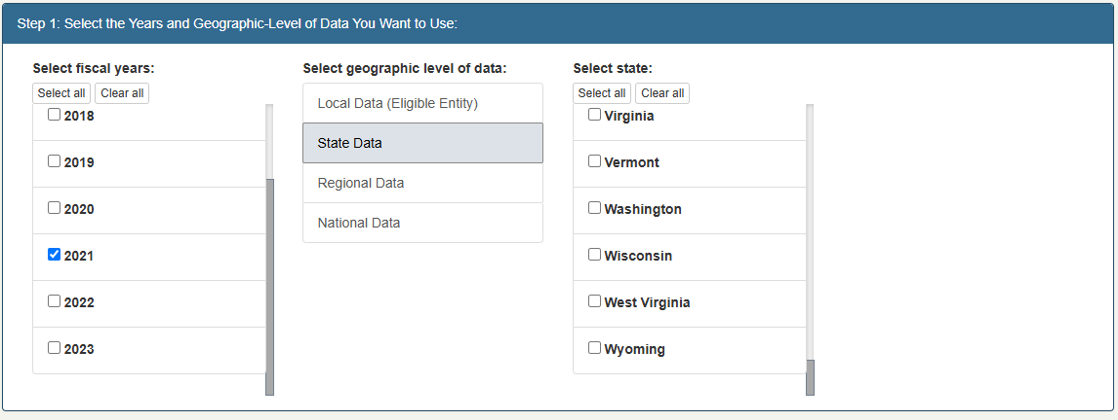

STEP 3: Under step 2 of the customize screen, we do not want to make any changes to the parameters already selected.

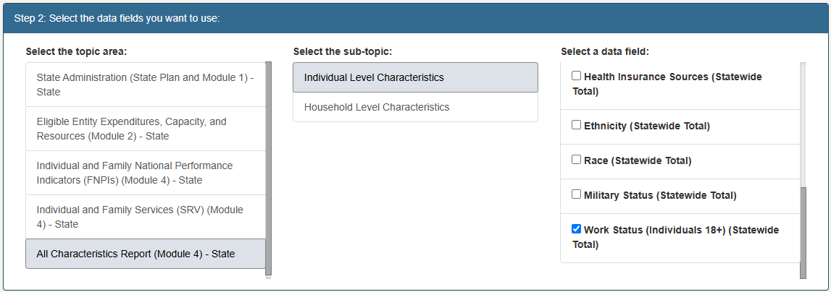

STEP 4: Under Step 3, we will select all deselected columns (the types of work) and deselect “Unknown/Not Reported” and “Total.”

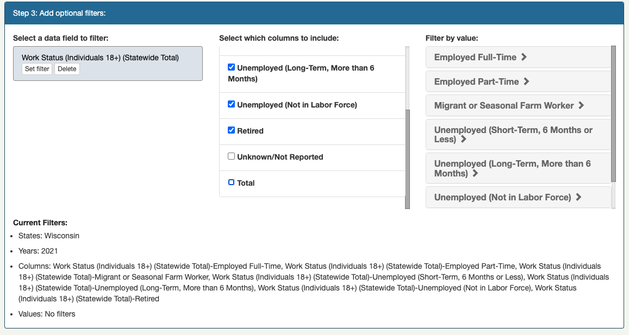

STEP 5: Under Step 4, ensure that “Bar graph” is still selected. You can update the title as needed, then click “Create Data Report.”

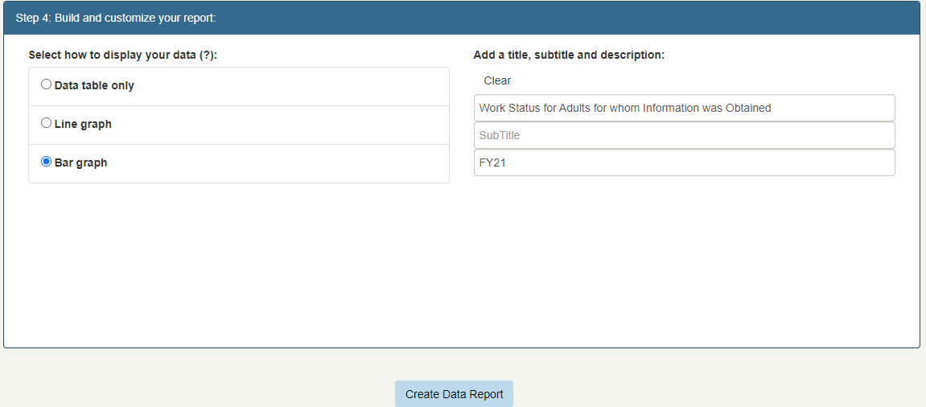

Scenario 6 Result

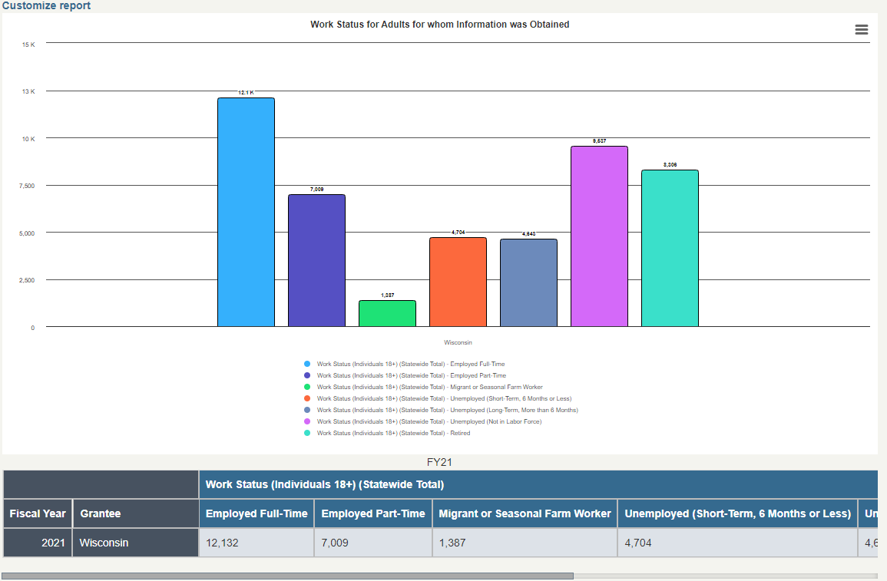

Scenario 6

